**GUIDELINES FOR AUTHORS FOR PREPARING MANUSCRIPTS**

**TITLE: BOLD, UPPER CASE, TIMES NEW ROMAN, 14 PT CENTERED**

First A. Author1[1], Second B. Author1, Third Author2, Fourth C. Author3

1Briham Young University, 360G EB, Provo, UT 84602, USA

2ISAE-ENSMA, BP 40109, 86961 Futuroscope Chasseneuil Cedex, France

3Middle East Technical University, 06800 Çankaya Ankara, Turkey

ABSTRACT. This guide has been prepared for authors of papers to be presented at the Tenth ICHMT International Symposium on Radiative Transfer (RAD-23) to be held in Thessaloniki, Greece, on June 12-16, 2023. Authors are requested to follow these guidelines to achieve uniformity in the presentation of the proceedings. The main format of the paper is as follows: Text: Times New Roman (or equivalent), 12 pt type size, left and right justified. Headings: Times New Roman, all caps, 12 pt. type size, centered. Page size A4 (210 × 297 mm); 20 mm borders all round; paper title starts at 50 mm from top of the first page. The manuscript is transferred to a PDF file and is sent to Prof. Brent W. Webb, Symposium Co-Chair (E-mail: webb@byu.edu).

# 1. MANUSCRIPT PREPARATION

Manuscripts must be submitted in electronic form in PDF format, A4 size (210 × 297 mm). Any word processing utility (*e.g*., MS Word, OpenOffice, LaTeX) may be used to generate the manuscript provided that it is converted to PDF for submission and follows the format shown in this template. The text must be formatted using the templates, both in Word and LaTex, that are provided on the website.

The typing area of all pages should be 170 x 257 mm, with equal margins on left and right, top and bottom (20 mm each). Each page should be completely filled with typing and/or diagrams (except perhaps the last page). Authors should use Times New Roman, 12-point font for the text. They must assure that all symbols and equations will be correctly displayed in the PDF version. The text should be left and right justified and it should be single-spaced. If superscripts or subscripts make this a problem, wider spacing may be necessary. Put a blank line between paragraphs. Begin paragraphs flush at the left margin without indentation.

References should be numbered consecutively in the order they are mentioned[1], using Arabic numerals [2,3] in square brackets [4]. Page numbers must be included in the manuscript centered on the bottom of the second and subsequent pages.

# 2. PAPER LENGTH AND LAYOUT

**The total length of a paper, including all figures, tables and references, should not exceed 8 pages.** Manuscripts are therefore expected to provide a very concise description of the work being presented.They must, however, clearly state **the purpose, the methodology, the main results and the originality** of the study. The layout of the paper should follow the style of this document, starting with a title, name(s) of author(s) and affiliation(s).

**2.1 Title**

The title should appear **50 mm below the top edge** of the page. It should be brief, clear and descriptive. Use Times New Roman 14 pt. all bold capital letters (except if formulae or symbols appear in the title), centered on the width of the typing area. Authors’ names and affiliations should be in lower-case letters, not in bold. Leave one blank line between the title and the affiliation(s).

2.2 Abstract

A **brief** abstract (150 words) should appear beneath the affiliation of the author(s). It should give an account of the most relevant contributions of the paper. It is also important to indicate briefly the goal, the methods, the results, and conclusions. Avoid abbreviations, diagrams, and references. It must be complete and understandable without reference to the text. Leave two blank lines between the Author’s affiliation and the Abstract. Type the word ABSTRACT all in capitals, beginning at the left-hand margin, followed by a period and two letter spaces. Then begin typing the abstract itself in lower case and single space in block style. Leave two blank lines between the abstract and the first major heading.

**2.3 Footnotes**

The footnote of the first page contains the E-mail address of the corresponding author.

# 3. HEADINGS AND EQUATIONS

If your paper is divided into **sections** and **subsections**, please use the format adopted here, in which first-level headings are numbered as shown in bold capitals, 12 pt., centered on the line. Leave a two-line space above and a one-line space below.

**3.1 Second level headings**

Second level headings should be numbered with sub-section numbering shown in bold lower case (initial capital), left aligned. Leave one line space above and below.

*Third-level headings.* Third-level headings should be placed at the beginning of a paragraph. Capitalize only the first letter of the whole subhead and underline it (if possible, make the subhead italic); follow it by a period and one letter space; then begin typing the text on the same line and continue the text without indenting again. Leave one line space above.

*Equations, units, symbols, etc.* Equations should be typed neatly in position with a single line space above and below to distinguish them from the text. Use common fonts like Time New Roman in your math equations. Equations should be centered and assigned a number that should appear in parentheses flush to the right margin.

 (1)

and

 (2)

Subscripts and superscripts should clearly be typed as such, and the manuscript should be reviewed carefully to ensure there is no ambiguity in presentation. Numbers and letters that are intended to be subscripts or superscripts should not align with the rest of the text. Do not use punctuation at ends of equations. Align equal signs when equations stack with no intervening words. All data should be reported in SI units. Decimals should always be shown by periods and not by commas or centered dots.

# 4. FIGURES AND TABLES

4.1 Figures

Care should be taken to ensure that figures are contained within the typing area. All original drawings should be prepared, if possible, for a uniform scale of reduction. As a general rule, lettering in the figures should be comparable to that in the text.

Color and black and white photographs are allowed in digital format with sufficient resolution to permit high-quality reproduction, and imported into the manuscript. Color figures may also be accepted, again in digital format imported into the manuscript.

Figures should be numbered consecutively and referred to in the text unabbreviated, *e.g*., Figure 1, with a single letter space between the word “Figure” and the Arabic numeral. Place figures centered on the width of the text page as close as possible to their first mention in the text. Centered one line below the illustration, type the word “Figure” (in upper and lower case) and its number followed by a period and two-letter space. Then type the legend single-spaced, with an initial capital for the first word and for proper nouns only. Example:

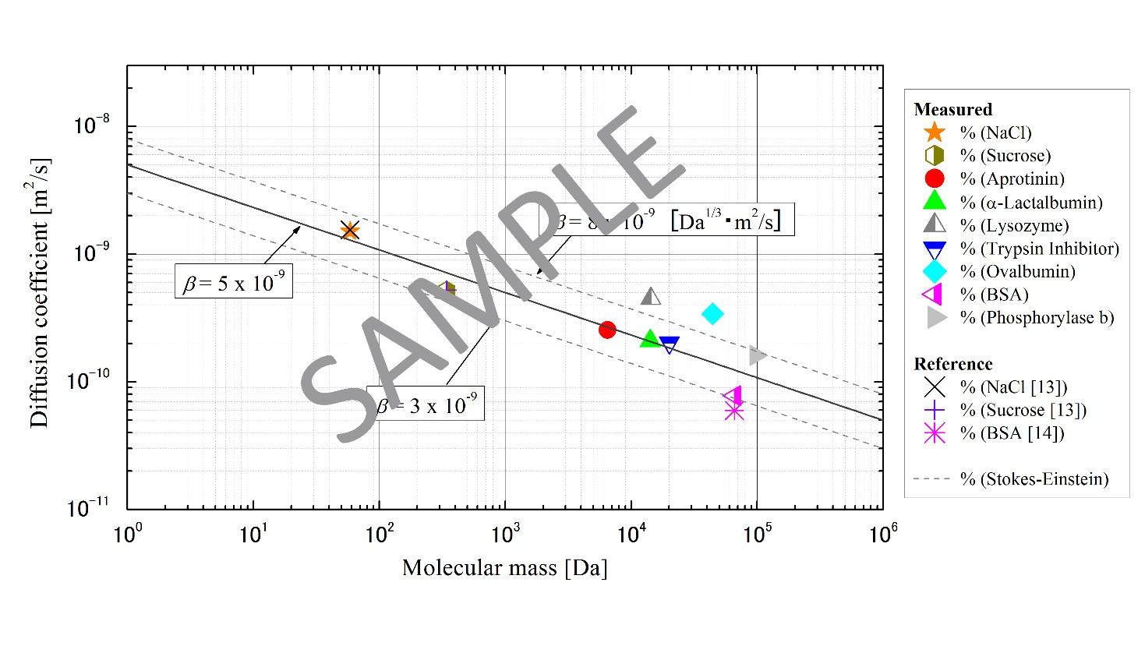

Figure 1. Figure captions are centered under the figure. Add one line space above the caption.

Each illustration should have at least a two-line space above the illustration, a one-line space between the illustration and the caption, and a two-line space between the caption and the start of the text.

## **4.2 Tables**

Table captions should appear above the respective table. Each table should have at least a two-line space both above the table and between the table and the start of the following text.

When tables are mentioned in the text, they should be referred to as Table 1, Table 5*, i.e*., with a single letter space between the word “Table” and the Arabic numeral. The first letter of the word “Table” should be capitalized, followed by the table number and colon, then the caption with the first letter of main words capitalized, all centered above the table as shown below. Use horizontal rules above and below to separate title from column heads, ranks within column heads, column heads from table body, and table body from table footnotes or source. For example:

Table 1: Comparison between Theory and Experiment

|  |  |  |  |  |
| --- | --- | --- | --- | --- |
| Date of test | Theoretical value  (cm) | | Experimental value (cm) | |
|  | Left | Right | Left | Right |
| January 1 | 17.45 | 3.81 | 16.98 | 3.99 |
| March 3 | 21.43 | 6.45 | 22.56 | 6.91 |

Authors should ensure that a table does not flow from one page to the next page. Tables should occupy only as much space as is required.

# 5. NON-ENGLISH SPEAKING AUTHORS

Authors from non-English speaking countries are requested to find persons who are competent in English and familiar with the scientific language who can edit their manuscripts before submission. Reviewers must not be relied upon to make corrections of English expression, spelling, *etc*. As there is no copy editing stage for publication-ready manuscripts, it is the responsibility of authors to ensure that the presentation of their papers reaches the same high level as that of the work they describe.

# 6. CONCLUSION

All papers will be peer-reviewed. Any paper which does not address new and innovative aspects in the topics of the meeting may not be selected for presentation at the Symposium. In order to process the reviewing in time, please submit your manuscript in PDF format no later than **January 30, 2023** to Prof. Brent W. Webb, Conference Co-Chair, E-mail: [webb@byu.edu](mailto:webb@byu.edu).

**Paper Size**: A4 (210 × 297 mm).

**Margins**: 20 mm margins all round as. Paper title starts at 50 mm from top of the first page.

**Line Spacing**: Single-spaced with one blank line between paragraphs. No paragraph indentation.

**Justification**: Full justification.

**Page numbering**: Pages are to be numbered.

**Graphs, etc**.: Graphs, tables and photographs are to be included at the top or bottom of the page on which they are first mentioned if possible, on the next page if not, and not gathered together at the end of the paper.

# ACKNOWLEDGEMENT

Acknowledgement, if any, should be placed immediately following CONCLUSIONS.

# REFERENCES

**Reference List** at the end of the article should be numbered consecutively in the order they are mentioned, using Arabic numerals in square brackets [4] and formatted according to the following samples. References should be in Times New Roman, 10 pt. type size, justified copy, first line flush left, remaining lines indented (See Reference list example below).

[1] M. P. Menguc, R. Viskanta, “Radiative Heat Transfer in Three-dimensional Rectangular Enclosures Containing Inhomogeneous, Anisotropically Scattering Media”, *J. Quant, Spectrosc. Radiat. Transfer*, vol. 33, no. 6, pp. 533-549, 1985.

[2] P. J. Coelho, “Numerical Simulation of the Interaction between Turbulence and Radiation in Reactive Flows”. *Prog. Energy and Combust. Sci.*, vol. 33, no. 4, pp. 311–384, 2007.

[3] M. F. Modest, *Radiative Heat Transfer*, Third Edition, Academic Press, pp. 125-126, 2013.

[4] G. Erdas, “Free Vibration Analysis of Beams and Plates Using Finite Element Method”, M.Sc. Thesis, METU Mech. Eng. Dept., Ankara, 1983.

[5] F. Liu, J.-L. Consalvi, A. Fuentes, G. J. Smallwood, “Effects of Water Vapor Addition to the Air Stream on Soot Volume Fraction and Flame Temperature in a Laminar Coflow Ethylene Flame”, In *Proceedings of the 7th International Symposium on Radiation, Kusadasi, June 2-8, 2013*, paper RAD-13-CO2, 2013.

[6] Ma, T.M., “Effects of Geometrical Shapes of Reentrant Grooves on Boiling Heat Transfer from Porous Surfaces,” *Heat Transfer 1986*, Proc. of 8th Int. Heat Trans. Conf., vol. 4, pp. 2013–2018, 1987.

1. Corresponding Author: [f.author@affiliation.com](mailto:f.author@affiliation.com) (Times New Roman, 10 pt).